Department of Artificial Intelligence - Data Science and Machine Learning
Powered by:
BFSI Rules Engine & Claude AI
Core Modules:
- Loan Eligibility Checker
- Credit Score Analyzer
- EMI Calculator
- AI Financial Tips & Planning
Technology:
HTML, CSS, JavaScript, BFSI rule-based calculations and Claude AI integration.
Project Description
Project Overview:
The BFSI (Banking, Financial Services and Insurance) Financial Assistant is a web-based financial decision-support application designed to help users make informed financial decisions through a combination of rule-based financial analysis and AI-powered recommendations.

The project provides multiple financial services through a unified dashboard. The Loan Eligibility Checker evaluates a user's financial profile using information such as monthly income, requested loan amount, loan tenure and existing EMIs, and provides an estimated eligibility result. The Credit Score Analyzer helps users understand their credit health by displaying the credit score, score category and important factors such as payment history, credit utilization, credit age, credit mix and new credit inquiries.

The system also includes Credit Score Simulation, allowing users to understand different credit-score conditions and their potential financial implications. In addition, the AI Financial Tips & Planning module uses the user's age, income and risk profile to provide personalized recommendations related to tax saving, emergency funds, retirement planning and financial protection.

The application uses an interactive, dashboard-based interface with visual indicators, cards, gauges and financial metrics to make complex financial information easier to understand. The project combines traditional BFSI calculations with AI-based personalized financial guidance, providing users with a centralized platform for loan assessment, credit analysis and financial planning.

Objectives of the Project
The main objectives of the BFSI Financial Assistant project are:
- To develop a centralized BFSI platform that provides multiple financial services through a single user-friendly dashboard.
- To provide loan eligibility analysis by evaluating financial parameters such as income, existing EMIs, loan amount and tenure.
- To analyze credit health by displaying credit scores and explaining important factors such as payment history, credit utilization, credit age and credit mix.
- To provide credit score simulation so users can understand different credit-score conditions and their financial implications.
- To provide personalized financial recommendations based on user information such as age, income and risk profile.
- To use AI technology for financial guidance, including recommendations related to tax saving, emergency funds, retirement planning and financial protection.
- To simplify complex financial information through interactive dashboards, visual indicators, gauges and easy-to-understand financial metrics.
- To support better financial planning and awareness by combining rule-based BFSI calculations with AI-powered recommendations.
- To create an interactive and responsive interface that allows users to access financial analysis and recommendations efficiently.
- To demonstrate the practical application of AI in the BFSI domain for financial analysis, planning and decision support.
Key Features
1 Loan Eligibility Checker
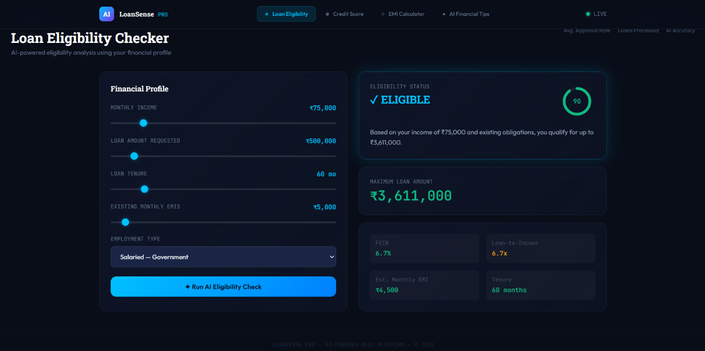
The Loan Eligibility Checker allows users to enter their financial profile and check their estimated loan eligibility using predefined BFSI rules.
The interface provides controls for:
- Monthly income
- Requested loan amount
- Loan tenure
- Existing monthly EMIs
- Employment type

After processing the entered information, the system displays the eligibility status, maximum eligible loan amount, estimated monthly EMI, FOIR and loan-to-income ratio.
In the displayed example, the user has a monthly income of ₹75,000 and existing monthly EMIs of ₹55,000. The system displays an Eligible status and provides an estimated maximum loan amount.
Figure: Loan Eligibility Checker – Financial Profile and Eligibility Result

Description:
This screenshot demonstrates how the user enters financial information and receives an instant loan eligibility analysis through the BFSI rules-based system.

2 Credit Score Analyzer
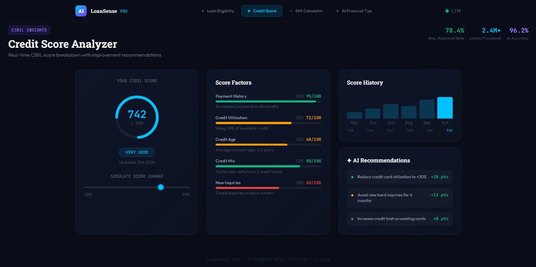
The Credit Score Analyzer provides an interactive representation of the user's credit score and explains the major factors that influence credit health.
The interface displays:
- Current credit score
- Credit score category
- Payment history
- Credit utilization
- Credit age
- Credit mix
- New credit inquiries
- Credit score history
- AI-based recommendations
The system also provides recommendations based on the displayed credit factors, such as reducing credit utilization and avoiding unnecessary hard inquiries.
Figure: Credit Score Analyzer – Good Credit Profile

Description:
The screenshot shows a credit score of 742/900, categorized as Very Good. A circular gauge provides a quick visual representation of the score, while the score-factor panel explains the contribution of different credit behaviors.

3. EMI Calculator
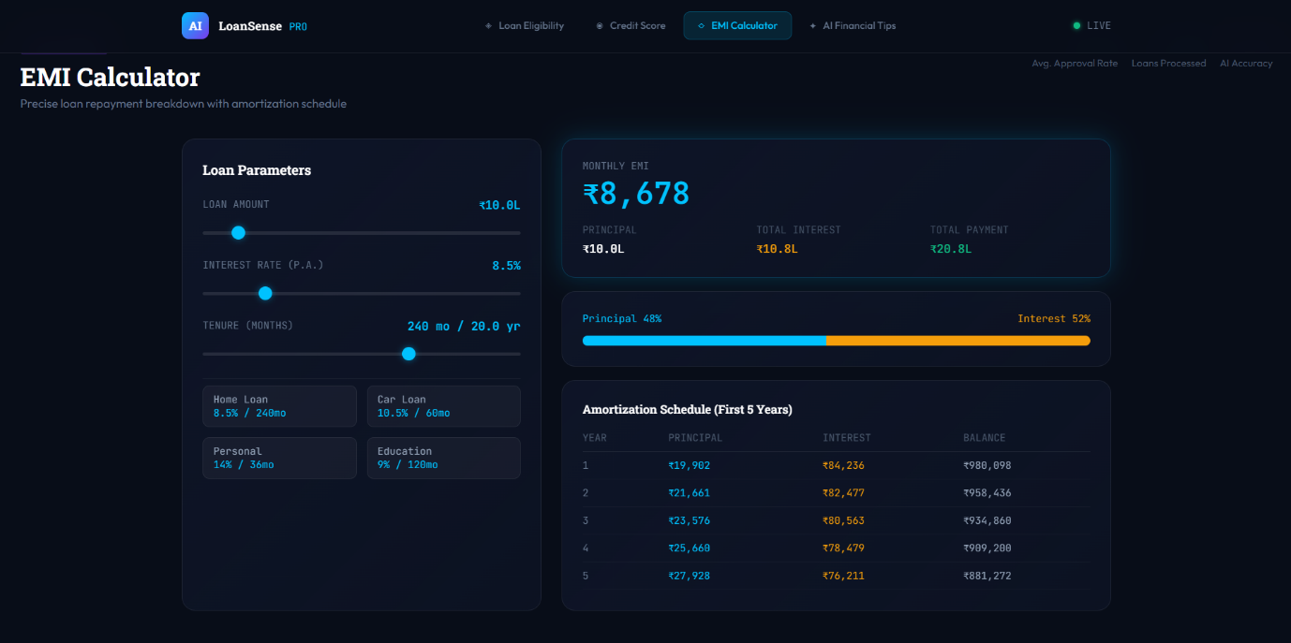
The EMI Calculator is a financial utility that helps users estimate the Equated Monthly Instalment (EMI) payable on a loan. It allows users to enter the loan amount, interest rate and loan tenure and calculates the corresponding monthly repayment.
Objectives
- To calculate the monthly EMI for a selected loan.
- To help users understand their monthly repayment obligation.
- To provide a quick estimate of the total interest payable.
- To support users in planning loan amounts and repayment periods.
Inputs
- Loan Amount (Principal)
- Annual Interest Rate
- Loan Tenure
Outputs
- Monthly EMI
- Total Amount Payable
- Total Interest Payable
EMI Formula
$$EMI=\frac{P×R×{\left(1+R\right)}^{N}}{{\left(1+R\right)}^{N}-1}$$
Where:
- P = Principal loan amount
- R = Monthly interest rate
- N = Total number of monthly instalments
The EMI Calculator can be included as a separate module in the BFSI project to help users evaluate the affordability of different loan options.

4 AI Financial Tips & Planning

The AI Financial Tips & Planning module provides personalized financial guidance based on the user's financial profile and selected risk preference.
The interface allows the user to specify:
- Risk profile
- Age
- Monthly income
Based on these inputs, the system presents financial suggestions under different categories.
The displayed recommendations include:
- Tax Saving – suggestions related to ELSS and tax deductions
- Risk Management – building an emergency fund
- Retirement – considering retirement-oriented investment options
- Protection – considering appropriate insurance coverage
The module uses Claude AI to provide interactive and personalized financial guidance.
Figure: AI Financial Tips – Personalized Financial Recommendations

Description:
This screenshot demonstrates the AI-powered financial planning interface. Based on the displayed user profile, the system generates recommendations related to tax saving, emergency funds, retirement planning and financial protection.

User Interface Design
The application follows a dark glassmorphism design with interactive cards, highlighted financial values, gauges and dashboard navigation.
The major UI elements visible in the screenshots include:
- Dark-themed background
- Glass-style information cards
- Blue and green highlighted values
- Interactive sliders
- Circular credit-score gauge
- Financial progress indicators
- Recommendation cards
- Dashboard navigation
- Responsive layout
The design helps present financial information in a visually understandable format rather than displaying only numerical data.

Project Workflow
Step 1 – Enter Financial Information
The user enters financial details such as income, loan amount, tenure and existing EMIs.
Step 2 – Loan Eligibility Analysis
The BFSI rules engine processes the information and generates an eligibility result.
Step 3 – Credit Score Analysis
The user can view their credit score and understand the factors affecting their credit profile.
Step 4 – Credit Score Simulation
The score can be simulated to demonstrate different credit-score conditions.
Step 5 – Financial Profile Selection
The user provides information such as age, income and risk profile.
Step 6 – AI Financial Guidance
Claude AI processes the user's financial context and generates personalized financial recommendations.
Step 7 – Display Results
All results are displayed through interactive dashboard cards and visual indicators.
The overall project combines rule-based financial calculations with AI-powered financial guidance

Testing and Verification
Test 1 – Loan Eligibility
Input:
Monthly income, loan amount, tenure, existing EMIs and employment type.
Expected Result:
The system processes the financial profile and displays the estimated loan eligibility and related financial indicators.
Test 2 – Credit Score Analyzer
Input:
Credit score/profile information.
Expected Result:
The system displays the credit score using an interactive gauge and presents the major credit-health factors.
Test 3 – Credit Score Simulation
Input:
Different simulated credit-score values.
Expected Result:
The system changes the displayed score and corresponding score category.
Test 4 – AI Financial Tips
Input:
Age, income, risk profile and financial requirements.
Expected Result:
The AI module displays personalized financial recommendations.
These testing objectives are consistent with the project's documented functional-testing approach.

Results:
The completed application demonstrates the following functionalities:
- Loan eligibility analysis
- Financial profile evaluation
- Credit score visualization
- Credit score simulation
- Credit-health factor analysis
- AI-generated financial recommendations
- Risk-based financial planning
- Tax-saving suggestions
- Emergency-fund guidance
- Retirement-planning suggestions
- Protection/insurance guidance
- Unified dashboard navigation
- Interactive financial components
The project therefore provides a single interface for several financial decision-support activities.

Conclusion:
The BFSI Financial Assistant successfully demonstrates the use of technology to simplify common financial activities through a single, interactive platform. The project integrates loan eligibility analysis, EMI calculation, credit score analysis, credit score simulation and AI-based financial planning into one dashboard.

The system helps users understand their financial position by presenting important information through clear visual indicators and structured recommendations. The AI-based financial tips further support personalized guidance based on factors such as income, age and risk profile.

Overall, the project demonstrates how AI and rule-based financial analysis can be combined in the BFSI domain to improve financial awareness, simplify financial calculations and provide users with accessible tools for basic financial planning and decision support.

